LEARNING OBJECTIVE 1:

1. As a Realtor that handles all the data on county websites, Christian wants to reduce the time it takes to search the Washington County websites via ParcelID numbers, and gather the information into an excel worksheet. Christian usually takes about 30 minutes per search to find the information, put all of it into excel sheets, and format it. This application/program will allow Christian to reduce that time and effort into just a few seconds. Christian will just have to type the parcel ID number into the excel doc, click search and the program will find and grab all the data, while exporting it into a new excel workbook, all formatted.

* Emailed Christian and introduced myself and tried to setup a meeting to get the project

Started

* 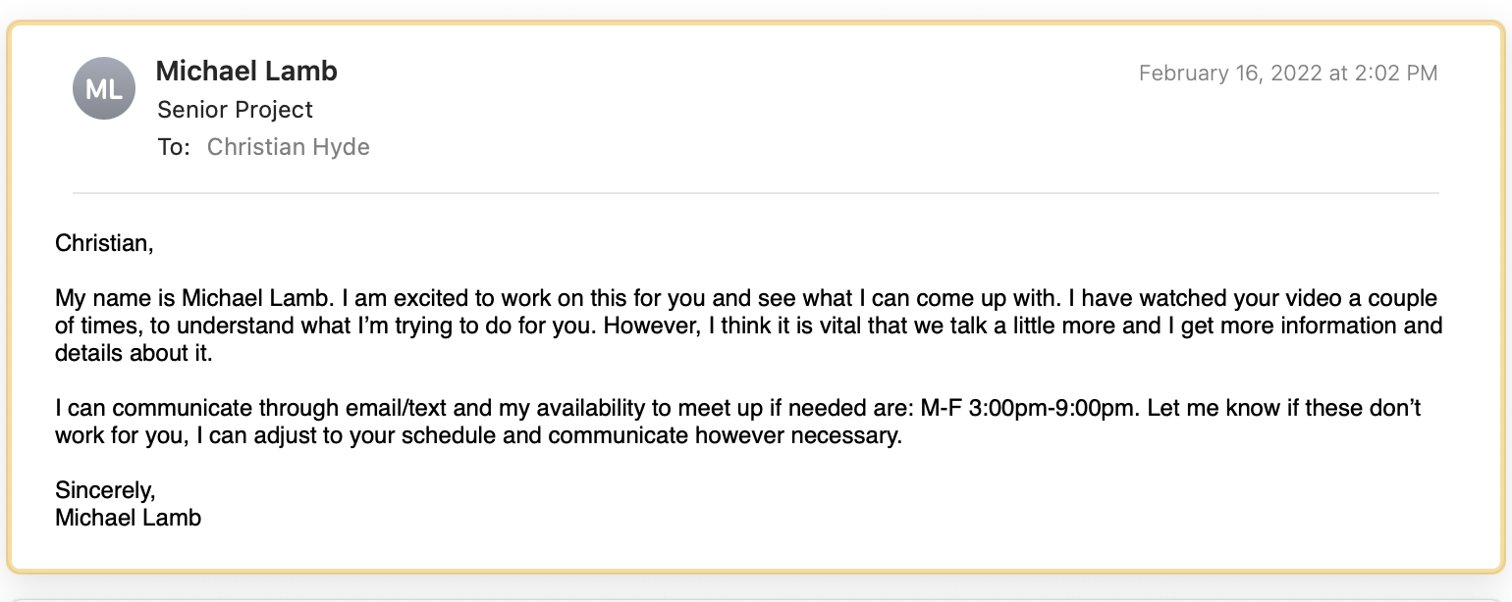
* 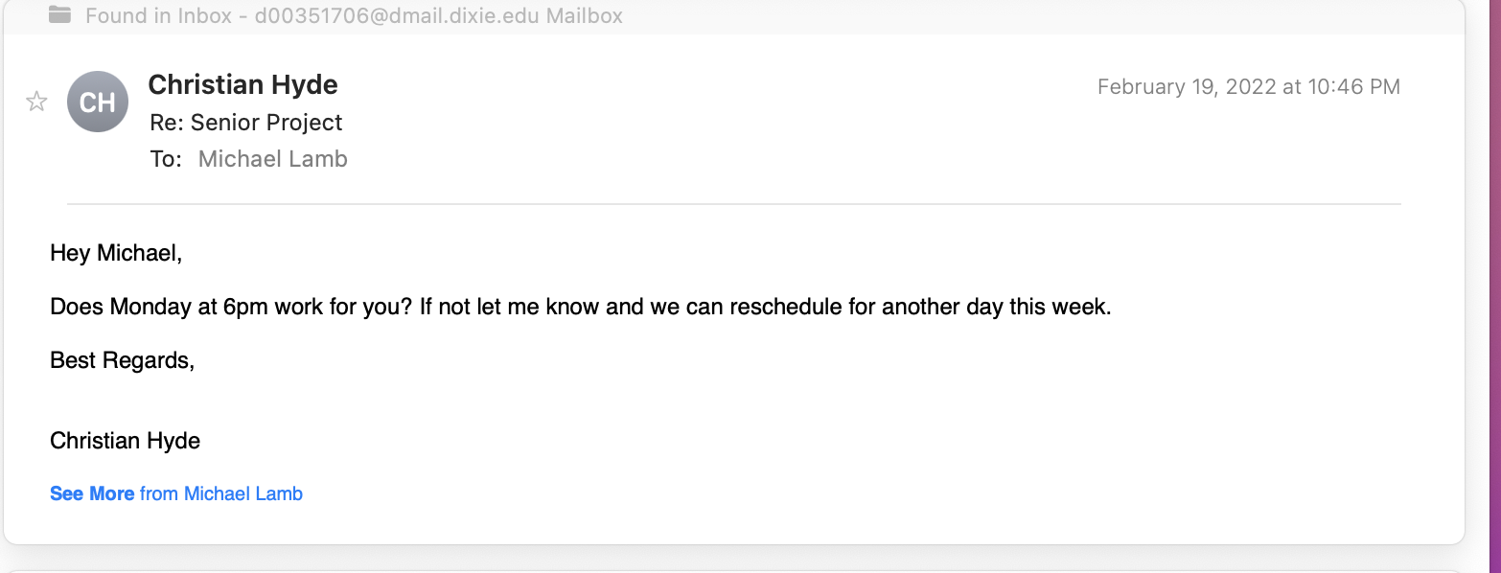
* After our meeting, Christian emailed me the information needed to get started.
* 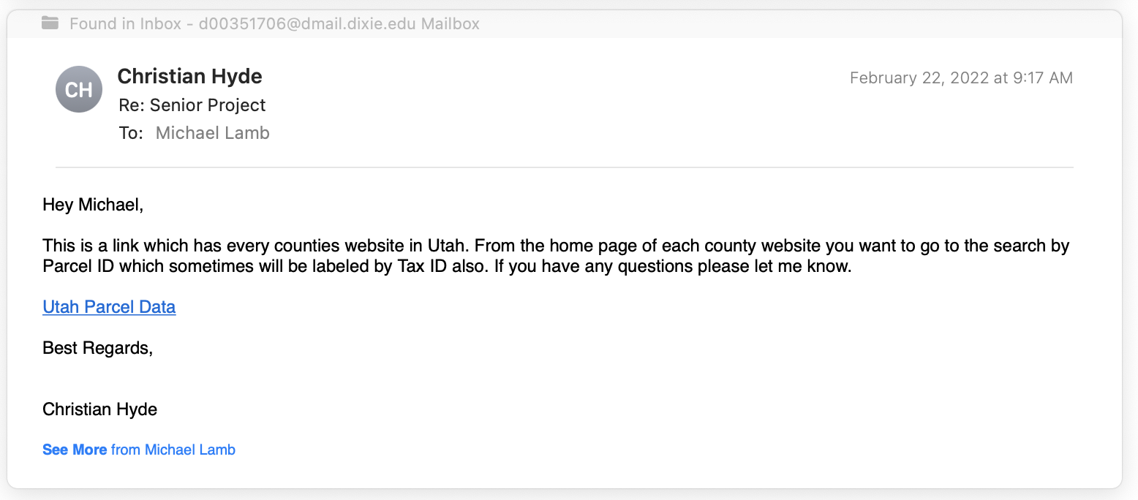
* I spent the next couple of months trying to figure out ways to get this working.

February 22 - 24, 2022, 2:00pm - 6:00pm: **- 8 hours**

Researching information and how to do what I was tasked

February 25 - March 1, 2022: 3 hours a day: **- 15 hours**

Found information and started to code

March 1, 2022:  **2 hours**

Came across some issues and asked for help with some coding issues through excel.

March 2 - 6, 2022 about 3 hours a day: - **15 hours**

Found ways around the issues and changed some code to continue

March 7, 2022:  **2 hours**

Another issue arose, couldn’t find the answers through research, and needed to ask

Matt Harris for advice.

March 8, 2022: **2 hours**

Decided to change tactics and start coding through python instead of VBA.

March 9 - April 10, 2022 about 3-4 hours a day, excluding some weekends - **78 hours**

Got all of my python code working and finding the information, but not exporting the table

data to excel. Images of codes and tries below:

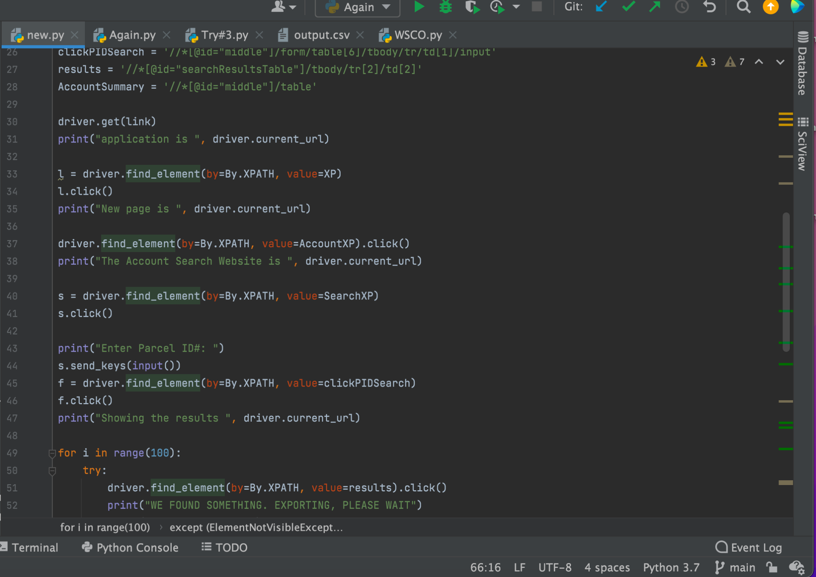

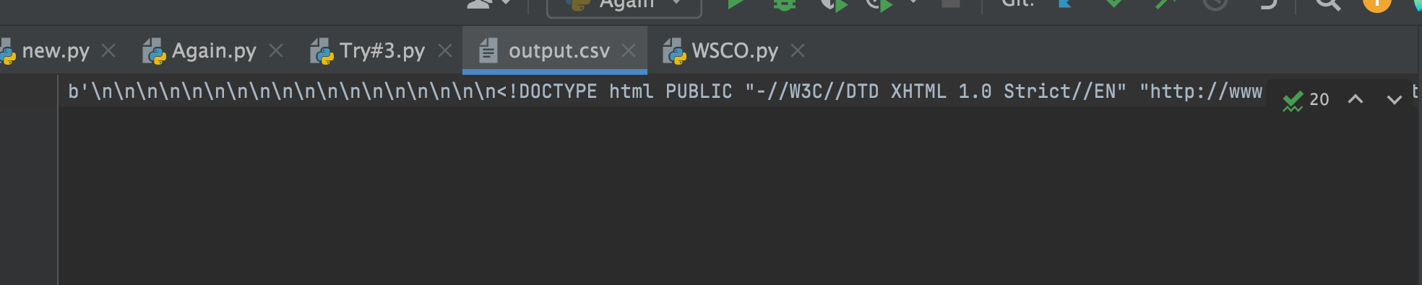

But output was not what I needed.

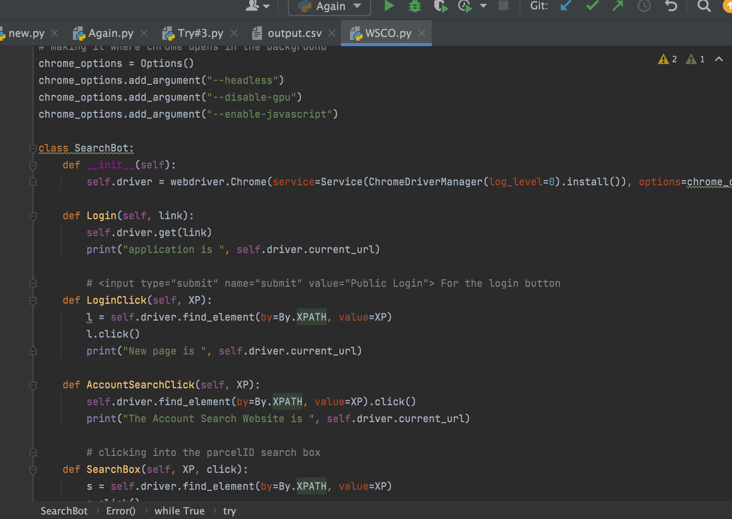

April 10, 2022: **2 hours**

Issues with the HTML and python grabbing the information.

Review info sent from Mr. Harris.

April 13, 2022:  **1 hour**

Changed back to VBA selenium

April 15, 2022:  **6 hours**

Coding and getting my selenium bot working

April 16, 2022: 6 hours or so: **6 hours**

Finished up my code and gathered the information and exported it. Ended with

formatting the output.

May 3, 2022: 1 hour: **1 hour**

I Met with Christian and showed him the project, gave him the files, and installed the

proper tools needed. Resolved some issues on the spot, got the excel file with macros to

work and do what it needs to do. Christian tried it out for a little and no issues arose.

**Total hours = 138**

LEARNING OBJECTIVE 2 AND 3:

1. VBA with selenium - Works through excel and uses macro references to use selenium that allows the bot to gather the information needed from the web and import the information.
   1. Drawbacks - Only works on Windows computers. MacOS does not have selenium type libraries on excel.
2. Selenium Python - Uses selenium packages into a python file to control the chrome browser to find and scrap the data into excel. It seems easier because I understand python a little better than other coding languages.
   1. Drawbacks - Had issues exporting the data into excel
      1. More coding required
3. Selenium Java - Same as the others, but uses Javascript language.
   1. Drawbacks - I don’t understand java that well compared to VBA or python and didn't have the time and resources to figure out JAVA for this project.

* I tried options 1 and 2. The easiest one to work with(since it can work on both windows and macOS with only python installed) was Selenium python. Selenium python has more packages you can use to do the things needed. I found issues using python due to the HTML structure on the website that I was scraping data from, also using pandas or requests, it was giving me errors that “Javascript isn't enabled” that was my output. Therefore, I decided to try VBA again, which ended up being my choice and what I used to complete the project.

LEARNING OBJECTIVE 4:

* Selenium VBA in excel uses a selenium coded bot that opens a webpage, clicks on the things needed to click, searches what you set your value to, and find the information. It will try to find the webpage first via domain, if not found will cause an error. Next, when the webpage is found, it has to find the element that you coded it to find before it can click. If it is not found, it will try another website(if coded IF NOT reference),refresh, or give an error. That process will continue with everything it needs to click or search until the information is found.

After the information is found, it will grab the table data/results and export them into excel via elementTagID or other elements that are on the HTML code. Finally, after it grabs the information from the website and pulls the data into excel, it will need to be formatted so the information doesn't look all bundled up, and we can format it all using VBA code. So there is no other thing to do after you click search on the excel page.

LEARNING OBJECTIVE 6:

All files are included at the web link below:

<https://github.com/lambMJC/WebScrapping>